Project Design Phase-II

Data Flow Diagram & User Stories

|  |  |
| --- | --- |
| Date | 27 October 2022 |
| Team ID | PNT2022TMID17964 |
| Project Name | Project – Skill and Job Recommender |
| Maximum Marks | 4 Marks |

# Data Flow Diagrams:

A Data Flow Diagram (DFD) is a traditional visual representation of the information flows within a system. A neat and clear DFD can depict the right amount of the system requirement graphically. It shows how data enters and leaves the system, what changes the information, and where data is stored.

Example:

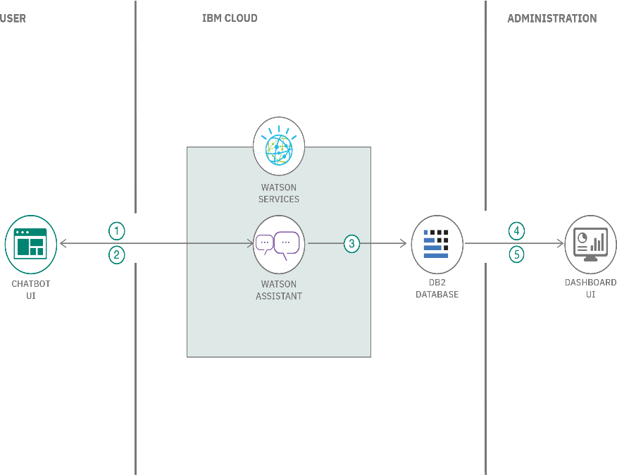

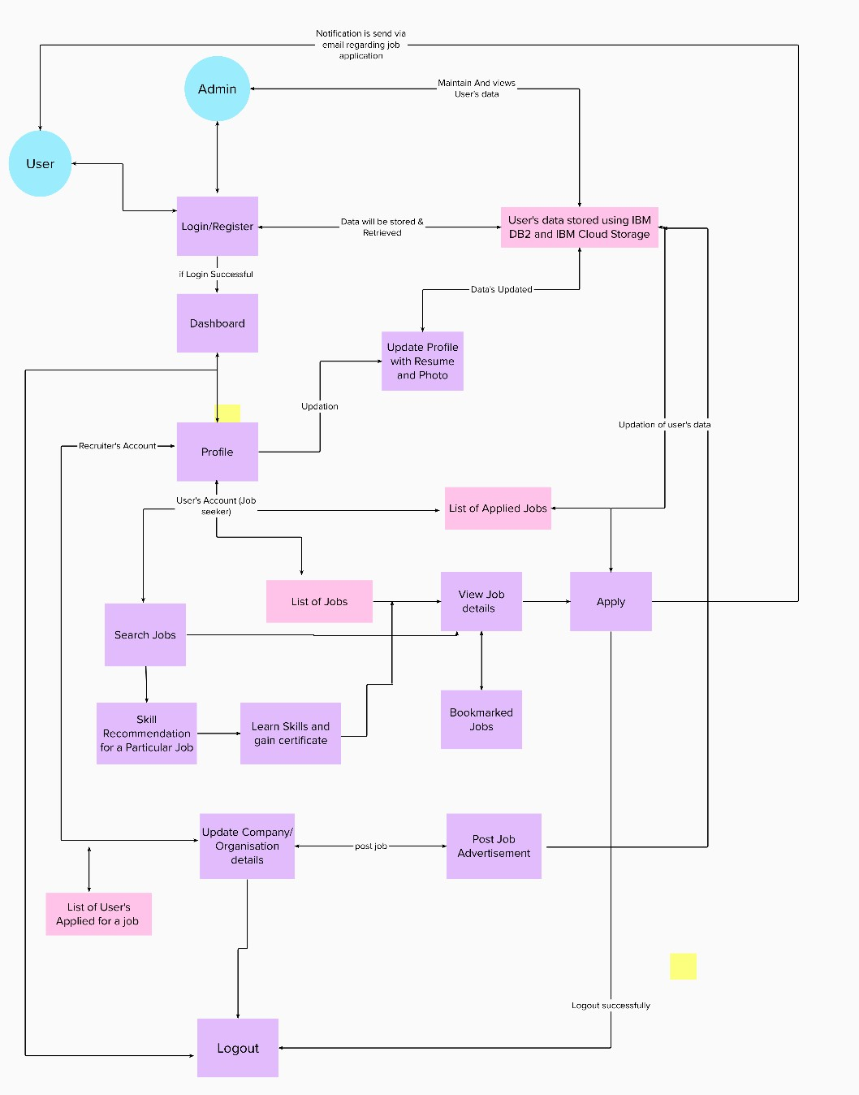

# User Stories

Use the below template to list all the user stories for the product.

|  |  |  |  |  |  |  |
| --- | --- | --- | --- | --- | --- | --- |
| **User Type** | **Functional Requirement**  **(Epic)** | **User Story Number** | **User Story / Task** | **Acceptance criteria** | **Priority** | **Release** |
| Customer (Mobile user) | Registration | USN-1 | As a user, I can register for the application by entering my email, password, and confirming  my password. | I can access my account / dashboard | High | Sprint-1 |
|  |  | USN-2 | As a user, I will receive confirmation email once I have registered for the application | I can receive confirmation email & click confirm | High | Sprint-1 |
|  |  | USN-3 | As a user, I can register for the application through online websites | I can register & access the dashboard with online website Login | Low | Sprint-2 |
|  |  | USN-4 | As a user, I can register for the application through Gmail | I can receive confirmation Gmail & click confirm | Medium | Sprint-1 |
|  | Login | USN-5 | As a user, I can log into the application by entering email & password | I can receive confirmation email & click confirm | High | Sprint-1 |
|  | Dashboard |  |  |  |  |  |
| Customer (Web user) |  | USN-6 | As a user, I can able to take up the skill assessment and view the appropriate test  score. Based on the skill sets I can able to get personalised job recommendations. | I can receive job recommendations | High | Sprint-1 |
| Customer Care  Executive |  | USN-7 | As a customer care executive, we provide  24/7 chatbot support. | 24/7 chatbot support | High | Sprint-1 |
| Administrator |  | USN-8 | As an administrator, I can able to view the progress and make required changes in the project | Deploy user specific and personalised job recommendations | High | Sprint-1 |
|  |  |  |  |  |  |  |
|  |  |  |  |  |  |  |
|  |  |  |  |  |  |  |